**WEB DEVELOPMENT**

***BY***

***MODALA VAYSHNAVI***

**1.Introduction**

**1.1 Overview**

E-Commerce or Electronics Commerce is a methodology of modern business, which addresses the need of business organizations, vendors and customers to reduce cost and improve the quality of goods and services while increasing the speed of delivery. Ecommerce refers to the paperless exchange of business information using the following ways −

* Electronic Data Interchange (EDI)
* Electronic Mail (e-mail)
* Electronic Bulletin Boards
* Electronic Fund Transfer (EFT)
* Other Network-based technologies

**1.2 Purpose**

What is the Purpose of Ecommerce Websites?

With the evolution of technology and the wave of digitalization, more and more businesses are adapting to tech evolutions. You will find the digital payment options with the grocery sellers & street-side vendors as well. The ultimate purpose behind this evolution is to make shopping a hassle-free experience for everyone.

If you are also non-techies who want to take their business online, Builderfly can be your savior. Builderfly is an ecommerce platform exclusively designed for individuals & businesses to start selling online, market & grow their business without any technicalities. So take your business to the World at your own pace**.**

**2.Literature Survey**

**2.1 Existing Problem**

On reviewing the literature it became evident that previous researchers adopted a high-level approach to the development of Web site design models. The models were designed to be adapted to multiple industries resulting in broad categories. The literature has uncovered three main ways of classifying Web sites. The digital business model, e.g. Wen, Chen and Hwang (2001) and Schneider and Perry (2001) describe ways in which business can be conducted over the Web. The stages of development model, e.g. Ho (1997), Burgess and Cooper (1999), Boon, Hewett and Parker (2000), Lowe (2001), Becker (2002) and Davidson (2002) describes different stages of development with functionality mapped to each stage. In scoring systems, e.g. Elliot (2002), Cast Bobby (1999) and Gartner (2002), specific features of a Web site are identified and given a score**.**

**2.2 Purposed Solution**

Researchers have defined e-commerce in many versions. Using the Organization for Economic Cooperation and Development (OECD) version, e-commerce can be defined as [3]: “The sale or purchase of goods or services, conducted over computer networks by methods specifically designed for the purpose of receiving or placing of orders.

The goods or services are ordered by those methods, but the payment and the ultimate delivery of the goods or services do not have to be conducted online. An e-commerce transaction can be between enterprises, households, individuals, government, and other public or private organizations. To be included are orders made over the web, extranet or electronic data interchange. The type is defined by the method of placing the order. To beexcluded are orders made by telephone calls, facsimile or manually typed e-mail.

**3.Theoretical Analysis**

**3.1 Block Diagram**

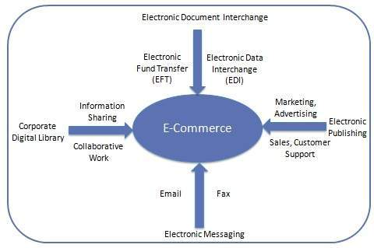

**Figure 1: Electronic Document Interchange**

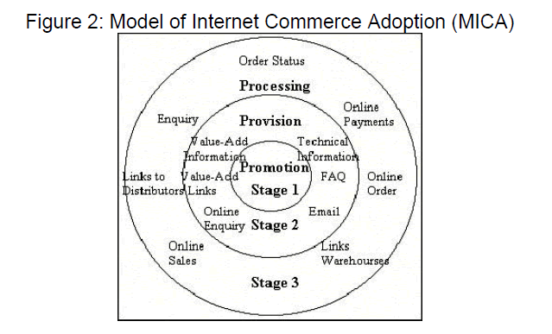

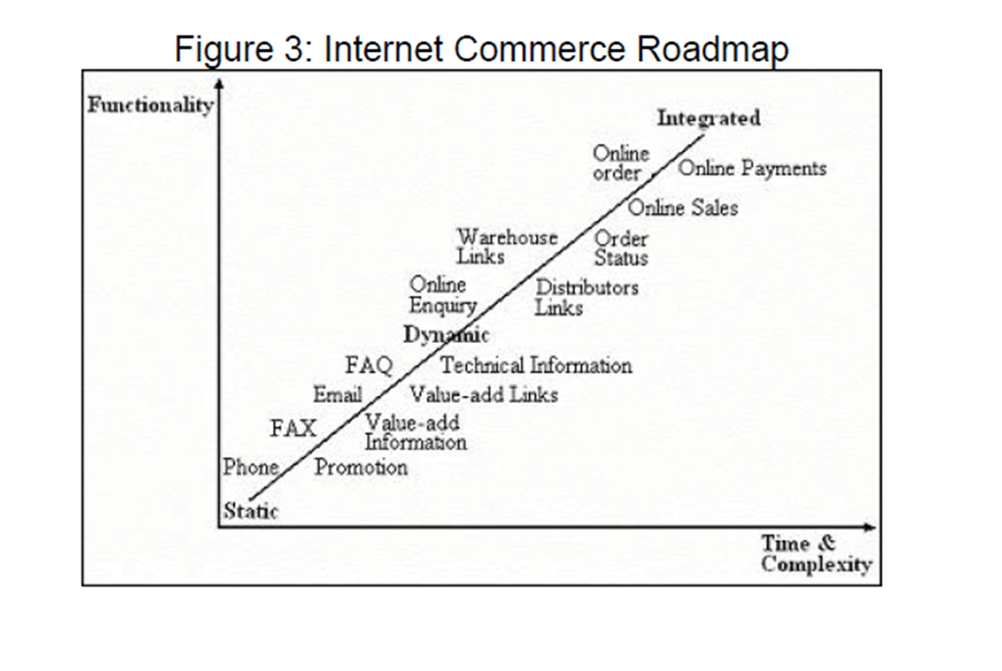

**3.2 Hardware/software Designing**

Web Server

Meaning

• It refers to a common computer, which provides information to other computers on the internet.

• It is either the hardware (the computer) or the software (the computer programs) that stores the digital information (web content) and delivers it through Internet whenever required.

The three components to a web server

• The Hardware

• Operating system software

• web server software

Website & Internet Utility Programs

Meaning of Website

• A Website is a collection of related web pages on a web server maintained by any individual or organization.

• A website is hosted on web server, accessible via internet or private LAN through an internet address called URL (Uniform Resource Locator). All publicly accessible websites collectively constitute the WWW (world wide web)

Meaning of Utility Programs

These are software tools to help users in developing, writing and documenting programs (asequence of instructions to a computer)

There are 2 types of utility programs

1) File Management Utilities – it helps in creating, copying, printing, erasing and renaming thefiles.

2) Program Development Utilities – it is useful in assembler, compiler, linker, locator etc,Website & utility programs include:

* Electronic Mail – sending & receiving messages globally via internet.
* Use Net News – it’s a software that enables a group of internet users to exchange their view, ideas, information on some common topic of interest with all members belonging to the group.

Ex:-politics, social issues, sports etc.

* Real Time Chatting – It is an internet program available to users across the net to talk to eachother, text messages, video chat and video conference via internet.

Finger and Ping

* Finger – it is the utility program used to find some information about the users that are on the network. Ex: - last time a user logged on to the network
* Ping (Packet Internet Groper) – it is a program used to test the connectivity between two computers connected to the internet. Connection with the internet to ensure proper network
* Tracer (Route Tracing Program) – it is a program that sends data packets to every computer on the path between one computer to another computer in the network and records the time it takes to reach the destination computer from the originating computer.

Telnet and FTP

Telnet – it is a software that allows one computer user to access files and run programs on another computer that is connected to the internet.

FTP - (FILE TRANSFER PROTOCOL)

It is a service used on internet to exchange files between computer. Indexing & Searching Utility programs it helps the search engine to search the specific website (Search for Information)

Data Analysis Program – it is software used to obtain the visitor information. i.e., website visitor is accessing, time lag the website viewed, the date and time of each visit, pages viewed etc.,

Line checking utility program – it examines each page on the website and reports any URLsbroken or someway incorrect. Besides checking links, link checker programs sometimes checkspelling and other structural components of web pages.

Remote Server Administration Program – this software allows the web administrator to manage and monitor a website from any Internet connected computer.

Web Hosting

It means to store website contents on a web server. It is a type of service, provided by Internet. Service Providers that allow individuals and organizations to make their website accessible when people browse via the www. Thus, web hosts are companies that provide space on a server owned or leased for use by clients.

There are two choices to host the website: -

i) On own web server platform (in house)

ii) On the platform of someone else (i.e., ISP's)

TYPES OF WEB HOSTING - Choice of web hosting

• Home Server – it is a single machine placed in a private residence used to host one or few websites from a broadband connection.

• Free Web Hosting service – it is the type of service provided by web hosting companiesfree of cost with limited services. The hosting companies offer free space on their web server with a condition that some advertisements are allowed on the web pages. Later the business can change the package by paying.

• Shared Website Hosting - it refers to hosting of multiple websites simultaneously on the same web server. The web host also maintains the server and provides technical support on it.

• Virtual Dedicated Hosting – In this type the client or user will have a dedicated web server with separate bandwidth and RAM. The user will be given ID and password to maintain the web server – the user can install or remove any software.

• Dedicated Hosting – the service provider makes a web server available to the client and has control over it. The service provider owns server hardware and software but leases it to the client.

• Managed Hosting – in this type ,the client user gets his own web server but is not allowed full control on it.(no install or remove software)

• Collocation Hosting – in this type the service provider rents a physical space to the client to install his/her server hardware. In other words, co-location allows a client to put his machine in a service provider's premises to avail all the available facilities. The client installs his own software and maintains the server. The service provider isresponsible only for providing a reliable power supply, internet connection and other networking hardware.

• Cloud hosting – it is a new type of hosting platform that allows clients a decentralized,powerful, scalable (i.e., can be upgraded or a new server added as necessary) and reliable hosting, based on clustered load-balanced servers and utility billing. A cloud hosted website may be more reliable than other choices since other computers in the cloud can compensate when a single piece of hardware goes down.

• Clustered Hosting -Multiple servers hosting the same content for better resources is called Clustered Hosting.,,

• Grid Hosting – it is a form of distributed hosting where a server clusters acts like a grid and is composed of multiple clients.

E-commerce Requirement

Telecommunication Infrastructure Requirements – it is entailed with bandwidth and security.Bandwidth varies from one e-commerce to another. Two main components of securityrequirements for e-commerce are type of firewall and encryption/algorithm mechanism. Security requirements area crucial part of e-commerce.

Hardware Requirement for E-commerce - Pentium II/III based Intel server running Linux canserve hundreds of unique customers each day. Low traffic sites can be easily served from a single machine depending on the needs of the business. High traffic sites require a backup of servers which automatically takes over operations in case of failure of primary ones.

Software Requirements for E-commerce – Several software are available free on the internet that can be used to build e-commerce exchanges. Ex:- Linux OS, mySQL database ,Apache webserver etc.,

Technical Skill -A systems administrator must have a good knowledge of computer hardware,must be able to maintain and upgrade hardware including hard drive, processor and motherboard.He/she must also have the skill to install and compile Apache, MySQL and Java servlet engine.

Financial Infrastructure -

i) Dependable telecommunication network

ii) Use of integrated banking software for ack office and front office data processing

iii) Use of WAN and internet for banking operations

iv) Availability of legal infrastructure supporting online payment mechanism.

V) Availability of EFT

Legal and Policy framework – policies that ensure legal certainty, security and consumerprotection for online transactions and interactions should be enacted. These include theresolution of issues such as transactional security, electronic contract enforceability andauthentication of individuals and documentation.

**E-commerce software**

Catalogue display

A catalogue is an organized list of goods & services being sold. An e-catalogue is a simple list of goods and services in HTML form that appears on a webpage on the website of an ecommerce company.

Two types

(i)static catalogue -providing simple list of goods and services on offer.

(ii) dynamic catalogue -providing a detailed feature about items on sale in a database, detaileddescriptions, shipment time etc.,

Shopping Cart

It is an electronic basket provided by E-commerce service providers to be used by net users to keep track of the products selected in the basket, compare and review them, modify it by adding new ones or removing unwanted goods before finally deciding to purchase. After the shopping is completed the customer will make the payment through online.

Features or Procedures for Shopping cart

• Compare and select the goods before purchasing.

• Select the goods easily -by clicking.

• Customize the product based on the size, quantity, colour etc., before proceeding to order.

• Getting information about the offers, discounts & price.

• Specify the payment mode like credit card, debit card, cheque, online payment, payment at the time of delivery etc.,

• Mention the venue for delivery of selected goods.

• Compute shipping charges and obtain information about taxes to incur.

• Get information about delivery time.

• Have transaction confirmation message and transaction report through an email or SMS.

• Transact securely with the web seller.

• Transaction Processing

It is the software that prompts processing the transaction when an online customer orders for a purchase. Transaction processing software calculates volume discounts to be allowed, sales tax or VAT to be charged; shipment cost etc., and arranges to receive payment as agreed. It also maintains the sales and inventory management modules in accounting software.

Additional component of e-commerce software includes: -

1) Middleware – it is the software that establishes the connection between e-commercesoftware, accounting and inventory management databases or application.

2) Enterprise Application Integration- it performs a specific function such as creatinginvoices, calculating payrolls, processing payments, etc., logically integrates them.

3) Enterprise Resource Planning (ERP)- It is a software package that integrates all facets ofbusiness, including accounting, logistics, manufacturing, marketing, planning, and financefunction. Example: -SAP

4) Customer Relationship Management (CRM) – It is a software that conducts activities likesales automation, customer centre operations and marketing campaigns. It gathers information about customer activities on the company's website and meets they need.

5) Supply chain Management – it is a software which helps the companies to integrate planning and coordinates activities of supply chain partners with the aim of efficiently reaching customers.

6) Web service – it is a set of software’s and technologies that allow computers to use the web to interact with each other directly, without human operators directing the specific interactions.

**4.Experimental Investigation**

In this paper, we examined Web-based information systems (WIS) success and focused on User Satisfaction in the context of a consumer purchasing decision. The results indicate strong support for the research model consisting of three fundamental User Satisfaction components: Task Support Satisfaction (TSS), Decision Support Satisfaction (DSS), and Interface Satisfaction. The model explains approximately 50% of the variance in users' intention to use Web-based information systems. It is concluded that Decision Support Satisfaction plays an important role in Web-based information systems success. In light of these findings, implications for theory and practice are discussed.

This study uses mainly secondary data, which are journals and formal reports. Recent academic journals were selected, ranging from the year 2011 to 2015. The databases used are from IEEE and ScienceDirect. Google Scholar was used as the initial platform to gather relevant articles. The contents of each journal were browsed, and then collected. No new model or framework was derived from this study.

According to the researchers, usefulness is the degree to which user recognizes the commerce site to be beneficial and the user’s decision and perception to the business transaction are affected by this factor .

**5.Flowchart**

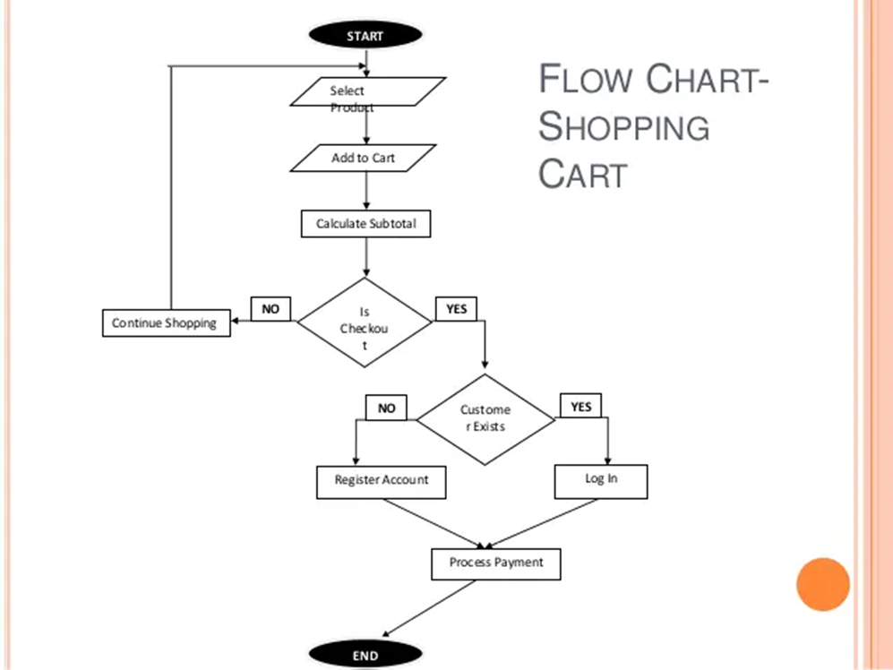

**6.Result**

Improving the ecommerce results of your business can only be planned using decision making data.

Changes to ecommerce infrastructure can cost many thousands of pounds and acting without information often proves very expensive.

Before you commit to change try our ecommerce report, our information may help to identify areas that may prove effective in growing your business while reducing your budget requirements.

This information can be used in discussions with others who may influence the management and maintenance of the ecommerce website and could aid in the decisions taken to develop, maintain, upgrade or change your ecommerce platform.

**7.Advantages and Disadvantages**

Advantages

* Using e-commerce, organizations can expand their market to national and international markets with minimum capital investment. An organization can easily locate more customers, best suppliers, and suitable business partners across the globe.
* E-commerce helps organizations to reduce the cost to create process, distribute, retrieve and manage the paper based information by digitizing the information.
* E-commerce improves the brand image of the company.
* E-commerce helps organization to provide better customer services.
* E-commerce helps to simplify the business processes and makes them faster and efficient.
* E-commerce reduces the paper work.
* E-commerce increases the productivity of organizations. It supports "pull" type supply management. In "pull" type supply management, a business process starts when a request comes from a customer and it uses just-in-time manufacturing way.

Disadvantages

There can be lack of system security, reliability or standards owing to poor implementation of e-commerce.

The software development industry is still evolving and keeps changing rapidly.

In many countries, network bandwidth might cause an issue.

Special types of web servers or other software might be required by the vendor, setting the e-commerce environment apart from network servers.

Sometimes, it becomes difficult to integrate an e-commerce software or website with existing applications or databases.

There could be software/hardware compatibility issues, as some e-commerce software may be incompatible with some operating system or any other component

**8.Applications**

Most common applications of Ecommerce:

Retail and Wholesale

Ecommerce has numerous applications in this sector. E-retailing is basically a B2C, and in some cases, a B2B sale of goods and services through online stores designed using virtual shopping carts and electronic catalogs. A subset of retail ecommerce is m-commerce, or mobile commerce, wherein a consumer purchases goods and services using their mobile device through the mobile optimized site of the retailer. These retailers use the E-payment method: they accept payment through credit or debit cards, online wallets or internet banking, without printing paper invoices or receipts.

Online Marketing

This refers to the gathering of data about consumer behaviors, preferences, needs, buying patterns and so on. It helps marketing activities like fixing price, negotiating, enhancing product features, and building strong customer relationships as this data can be leveraged to provide customers a tailored and enhanced purchase experience.

Finance

Banks and other financial institutions are using e-commerce to a significant extent. Customers can check account balances, transfer money to other accounts held by them or others, pay bills through internet banking, pay insurance premiums, and so on. Individuals can also carry out trading in stocks online, and get information about stocks to trade in from websites that display news, charts, performance reports and analyst ratings of companies.

**9.Conclusion**

As the digital economy is expanding rapidly and affecting more enterprises activities, it is important to take into consideration the proposed solutions for the mentioned issues and challenges of e-commerce business. Even though e-commerce enterprises could be from any types, basically they share the common issues and challenge.

**10.Future scope**

In terms of future of e-commerce in the 21st century, experts predict the promising and glorious figures. In the foreseeable future, e-commerce will be confirmed as the major tool of sale for the goods and services. Successful e-commerce will become the notion which will be inseparable from the web because e-shopping is becoming more and more popular and natural. Thus, prevailing to future trends, e-commerce will have huge potential growth in sales and promotion.

Each year, there is a continuous growth in e-commerce deals. The volumes of sales for online store are much higher than the brick and mortars. To the present day, the internet sales boom the foundation for magnificent e-commerce future. To attract more customers, owners will not only have to increase the number of services available to them but also have to pay more attention to such elements like design, good presentation, etc.

**11.Bibliography Appendix**

* [https://www.bigcommerce.com/ecommerce-answers/website-proposal/](https://www.bigcommerce.com/ecommerce-answers/website-proposal/https://www.netsolutions.com/insights/ecommerce-business-challenges-and-solutions/https://www.researchgate.net/publication/222658570_An_experimental_investigation_of_Web-based_information_systems_success_in_the_context_of_electronic_commerce)
* [https://www.netsolutions.com/insights/ecommerce-business-challenges-and-solutions/](https://www.bigcommerce.com/ecommerce-answers/website-proposal/https://www.netsolutions.com/insights/ecommerce-business-challenges-and-solutions/https://www.researchgate.net/publication/222658570_An_experimental_investigation_of_Web-based_information_systems_success_in_the_context_of_electronic_commerce)
* [https://www.researchgate.net/publication/222658570_An_experimental_investigation_of_Web-based_information_systems_success_in_the_context_of_electronic_commerce](https://www.bigcommerce.com/ecommerce-answers/website-proposal/https://www.netsolutions.com/insights/ecommerce-business-challenges-and-solutions/https://www.researchgate.net/publication/222658570_An_experimental_investigation_of_Web-based_information_systems_success_in_the_context_of_electronic_commerce)

Source code

1.Score the perfect domain name

2.Sign up to a hosting provider

3.Install WordPress

4.Install and configure WooCommerce

5.Add products

6.Choose a theme

7.Install additional plugins

8.Add content that converts

9.Make your site public